Weekly Revenue Report
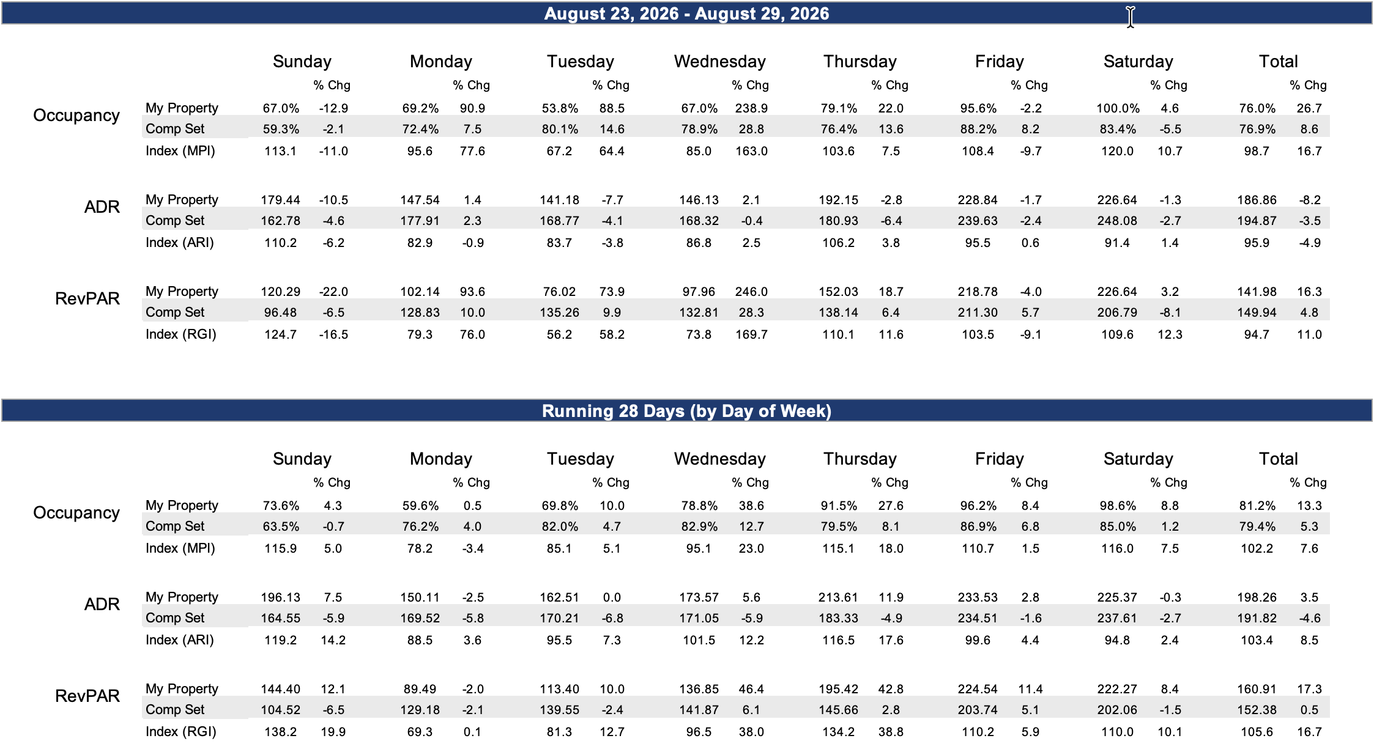
Segmentation

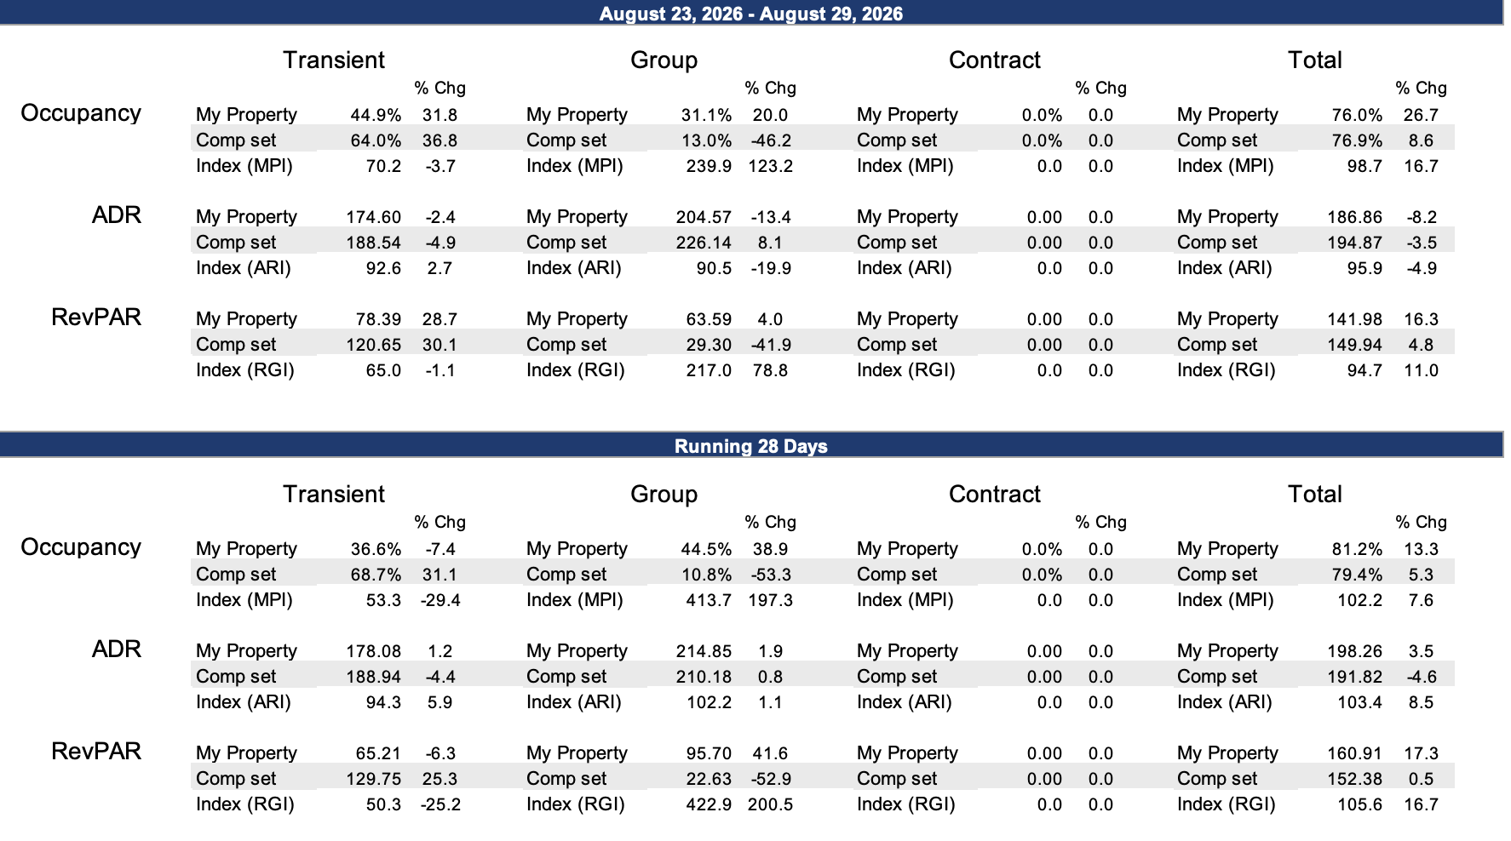

Day |  | Date | Wylie | The Wylie Inn | Salem Waterfront | Hawthorne Hotel | RIBM Boston North Shore /Danvers | Sonesta Select | Homewood Suites | Hampton Inn Salem
Wed | 09/02 |  | 54 | 210 | No flex | 329 | 189 | 139 | 199 | LOS2
Thu | 09/03 |  | 33 | 210 | No flex | 314 | 169 | 139 | 199 | 289
Fri | 09/04 |  | 0 | Sold out | No flex | Sold out | 239 | 299 | 199 | 469
Sat | 09/05 |  | 0 | Sold out | No flex | 399 | Sold out | 299 | Sold out | Sold out
Sun | 09/06 |  | 31 | 288 | No flex | Sold out | 189 | 299 | 233 | 479
Mon | 09/07 |  | 45 | 234 | No flex | 391 | 169 | 147 | 179 | 299
Tue | 09/08 |  | 26 | 189 | No flex | 453 | 169 | 149 | 179 | 299
Wed | 09/09 |  | 31 | 189 | No flex | 356 | 189 | 149 | 179 | 299
Thu | 09/10 |  | 4 | 234 | No flex | 356 | 189 | 149 | 189 | Sold out
Fri | 09/11 |  | 0 | Sold out | No flex | 431 | 309 | 299 | 232 | 469
Sat | 09/12 |  | 0 | Sold out | Sold out | Sold out | 309 | 354 | 339 | 529
Sun | 09/13 |  | 54 | 234 | No flex | Sold out | 169 | 149 | 179 | 369
Mon | 09/14 |  | 6 | 212 | Sold out | Sold out | 189 | 149 | 180 | Sold out
Tue | 09/15 |  | 3 | 230 | No flex | 375 | 259 | 263 | 289 | 489
Wed | 09/16 |  | 3 | 230 | Sold out | 361 | 189 | 270 | 289 | 369
Thu | 09/17 |  | 2 | Sold out | No flex | Sold out | 189 | 209 | 289 | Sold out
Fri | 09/18 |  | 0 | 288 | No flex | 450 | 329 | 399 | 309 | Sold out
Sat | 09/19 |  | 1 | Sold out | Sold out | Sold out | Sold out | 399 | LOS2 | Sold out
Sun | 09/20 |  | 53 | 234 | No flex | Sold out | 189 | 177 | 289 | 732
Mon | 09/21 |  | 31 | 198 | No flex | 458 | 179 | 149 | 179 | Sold out
Tue | 09/22 |  | 30 | 198 | No flex | 458 | 179 | 160 | 200 | 419
Wed | 09/23 |  | 27 | 198 | No flex | 329 | 179 | 156 | 180 | 429
Thu | 09/24 |  | 0 | Sold out | Sold out | Sold out | 189 | 242 | 191 | 599
Fri | 09/25 |  | 0 | Sold out | Sold out | Sold out | Sold out | 399 | Sold out | 1036
Sat | 09/26 |  | 0 | Sold out | Sold out | Sold out | Sold out | LOS2 | LOS2 | Sold out
Sun | 09/27 |  | 21 | 234 | No flex | Sold out | 189 | 231 | 289 | 519
Mon | 09/28 |  | 13 | 198 | No flex | Sold out | 189 | 184 | 219 | 789
Tue | 09/29 |  | 0 | Sold out | No flex | Sold out | 189 | 246 | 289 | 529
Wed | 09/30 |  | 19 | 198 | Sold out | 458 | 259 | 396 | 289 | 699
Thu | 10/01 |  | 42 | 351 | No flex | 606 | 359 | 364 | 399 | Sold out
Fri | 10/02 |  | 0/0 | Sold out | Sold out | Sold out | 489 | 719 | Sold out | 999
Sat | 10/03 |  | 0/0 | Sold out | Sold out | Sold out | 489 | LOS2 | Sold out | 999
Sun | 10/04 |  | 9 | 342 | No flex | Sold out | 229 | 349 | 369 | Sold out
Mon | 10/05 |  | 38 | 387 | No flex | Sold out | 309 | 349 | 369 | 699
Tue | 10/06 |  | 0 | Sold out | Sold out | Sold out | 309 | 359 | 369 | Sold out
Wed | 10/07 |  | 0 | Sold out | No flex | Sold out | 309 | 349 | 369 | 829
Thu | 10/08 |  | 64 | 369 | No flex | Sold out | Sold out | 349 | 399 | 849
Fri | 10/09 |  | 23 | 675 | Sold out | 645 | 509 | 719 | Sold out | 999
Sat | 10/10 |  | 0 | Sold out | Sold out | Sold out | Sold out | Sold out | LOS3 | Sold out
Sun | 10/11 |  | 42 | 477 | No flex | Sold out | 329 | Sold out | 369 | Sold out
Mon | 10/12 |  | 0 | Sold out | No flex | 559 | 309 | 349 | 369 | 599
Tue | 10/13 |  | 0 | Sold out | No flex | 579 | 309 | 349 | 369 | Sold out
Wed | 10/14 |  | 0 | Sold out | No flex | Sold out | 309 | 349 | 369 | Sold out
Thu | 10/15 |  | 22 | 387 | Sold out | Sold out | 329 | 349 | 399 | Sold out
Fri | 10/16 |  | 5 | 567 | Sold out | Sold out | 509 | 719 | Sold out | Sold out
Sat | 10/17 |  | 3 | 693 | No flex | Sold out | Sold out | Sold out | Sold out | Sold out
Sun | 10/18 |  | 53 | 333 | No flex | Sold out | 249 | 349 | 369 | 789
Mon | 10/19 |  | 44 | 333 | No flex | Sold out | 249 | 264 | 369 | Sold out
Tue | 10/20 |  | 17 | 333 | No flex | 635 | 249 | 298 | 367 | Sold out
Wed | 10/21 |  | 17 | 351 | No flex | 579 | 249 | 301 | 366 | Sold out
Thu | 10/22 |  | 0 | Sold out | No flex | 559 | 259 | 305 | 399 | 849
Fri | 10/23 |  | 1 | Sold out | Sold out | Sold out | 509 | 719 | Sold out | Sold out
Sat | 10/24 |  | 32 | 675 | Sold out | Sold out | 509 | LOS2 | Sold out | Sold out
Sun | 10/25 |  | 75 | 360 | No flex | Sold out | 299 | 260 | 369 | Sold out
Mon | 10/26 |  | 76 | 360 | No flex | 569 | 229 | 255 | 369 | 699
Tue | 10/27 |  | 76 | 360 | No flex | 569 | 229 | 311 | 369 | 699
Wed | 10/28 |  | 75 | 360 | No flex | Sold out | Sold out | 339 | 369 | 699
Thu | 10/29 |  | 64 | 360 | No flex | 559 | 329 | 349 | 399 | 769
Fri | 10/30 |  | 52 | 630 | Sold out | Sold out | 629 | 719 | Sold out | Sold out
Sat | 10/31 |  | 44 | 648 | Sold out | Sold out | Sold out | LOS2 | Sold out | Sold out

Booking.com

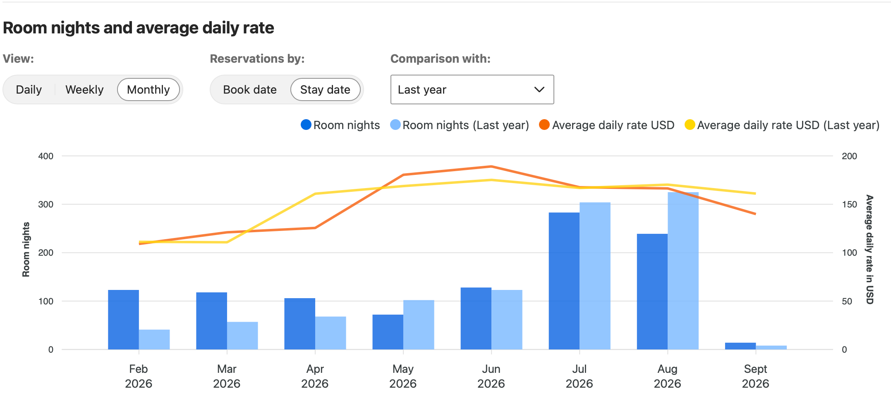
Comp Set
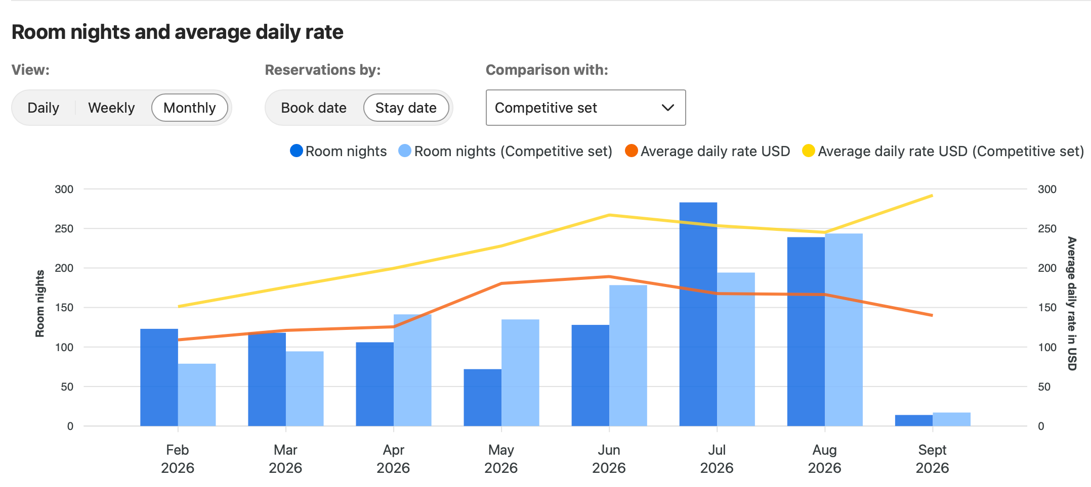

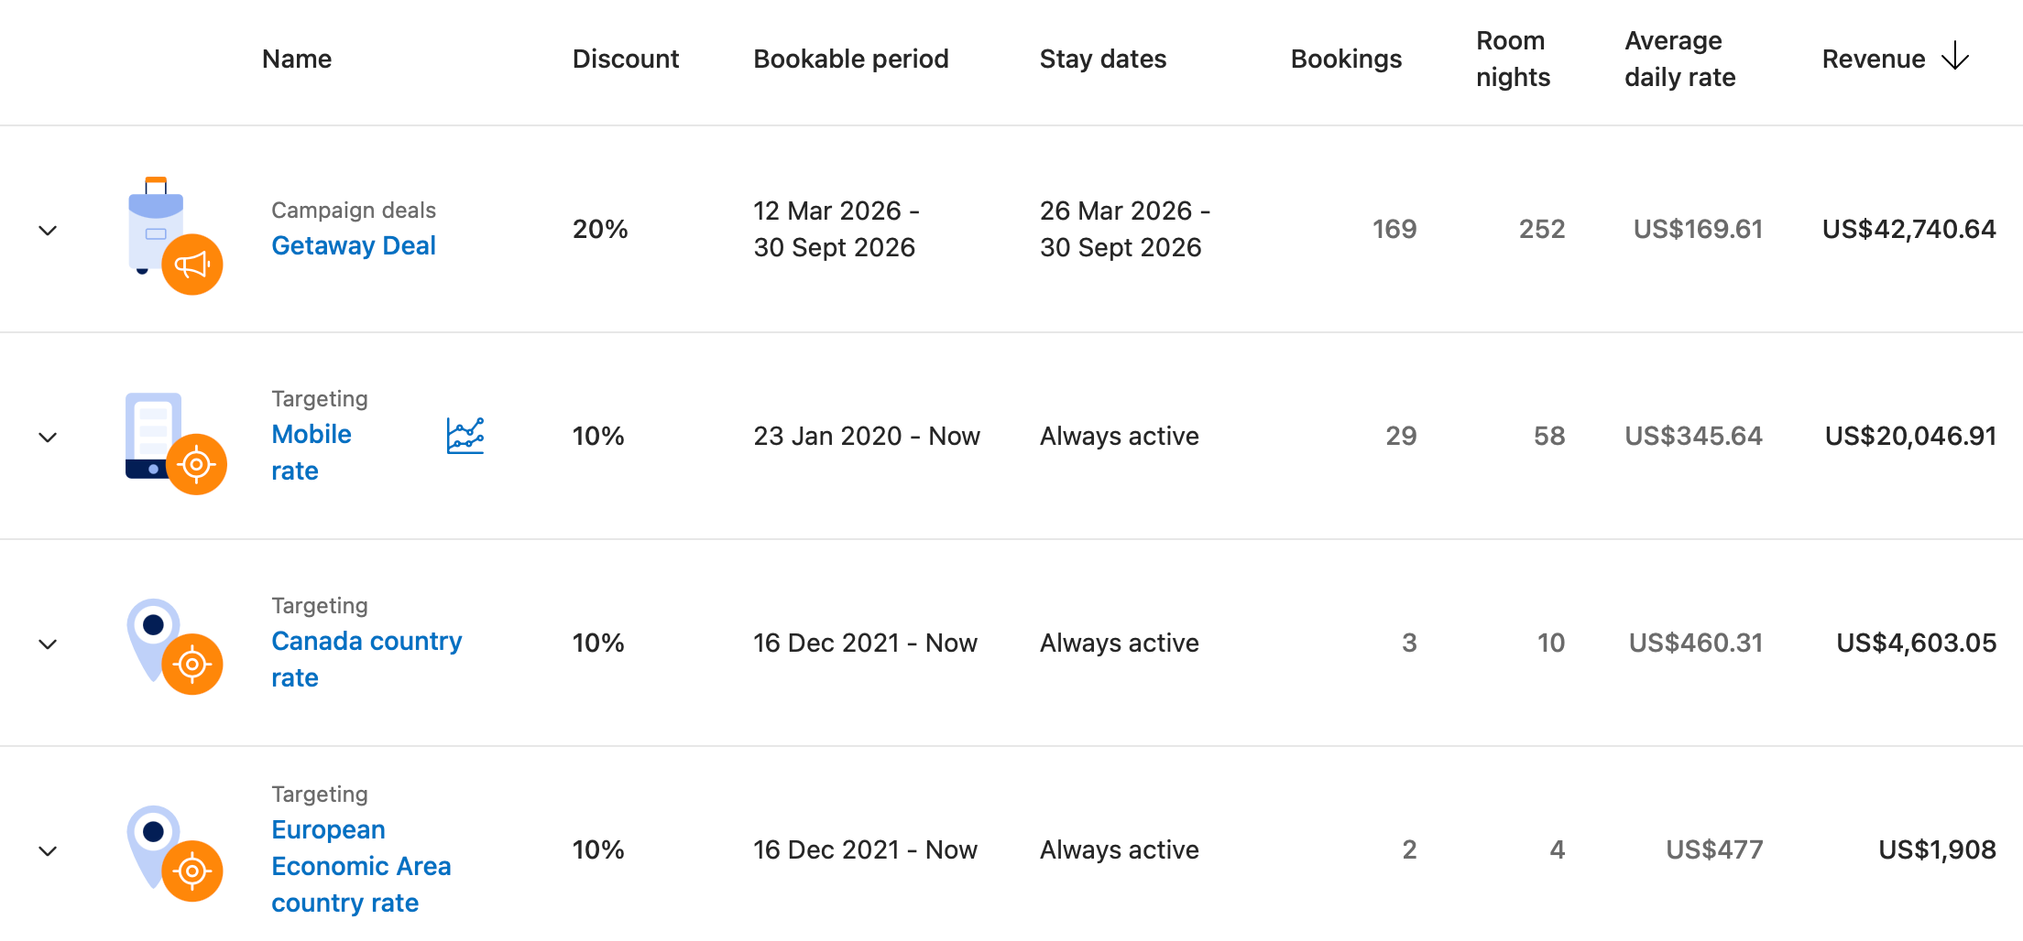

Expedia

Promotions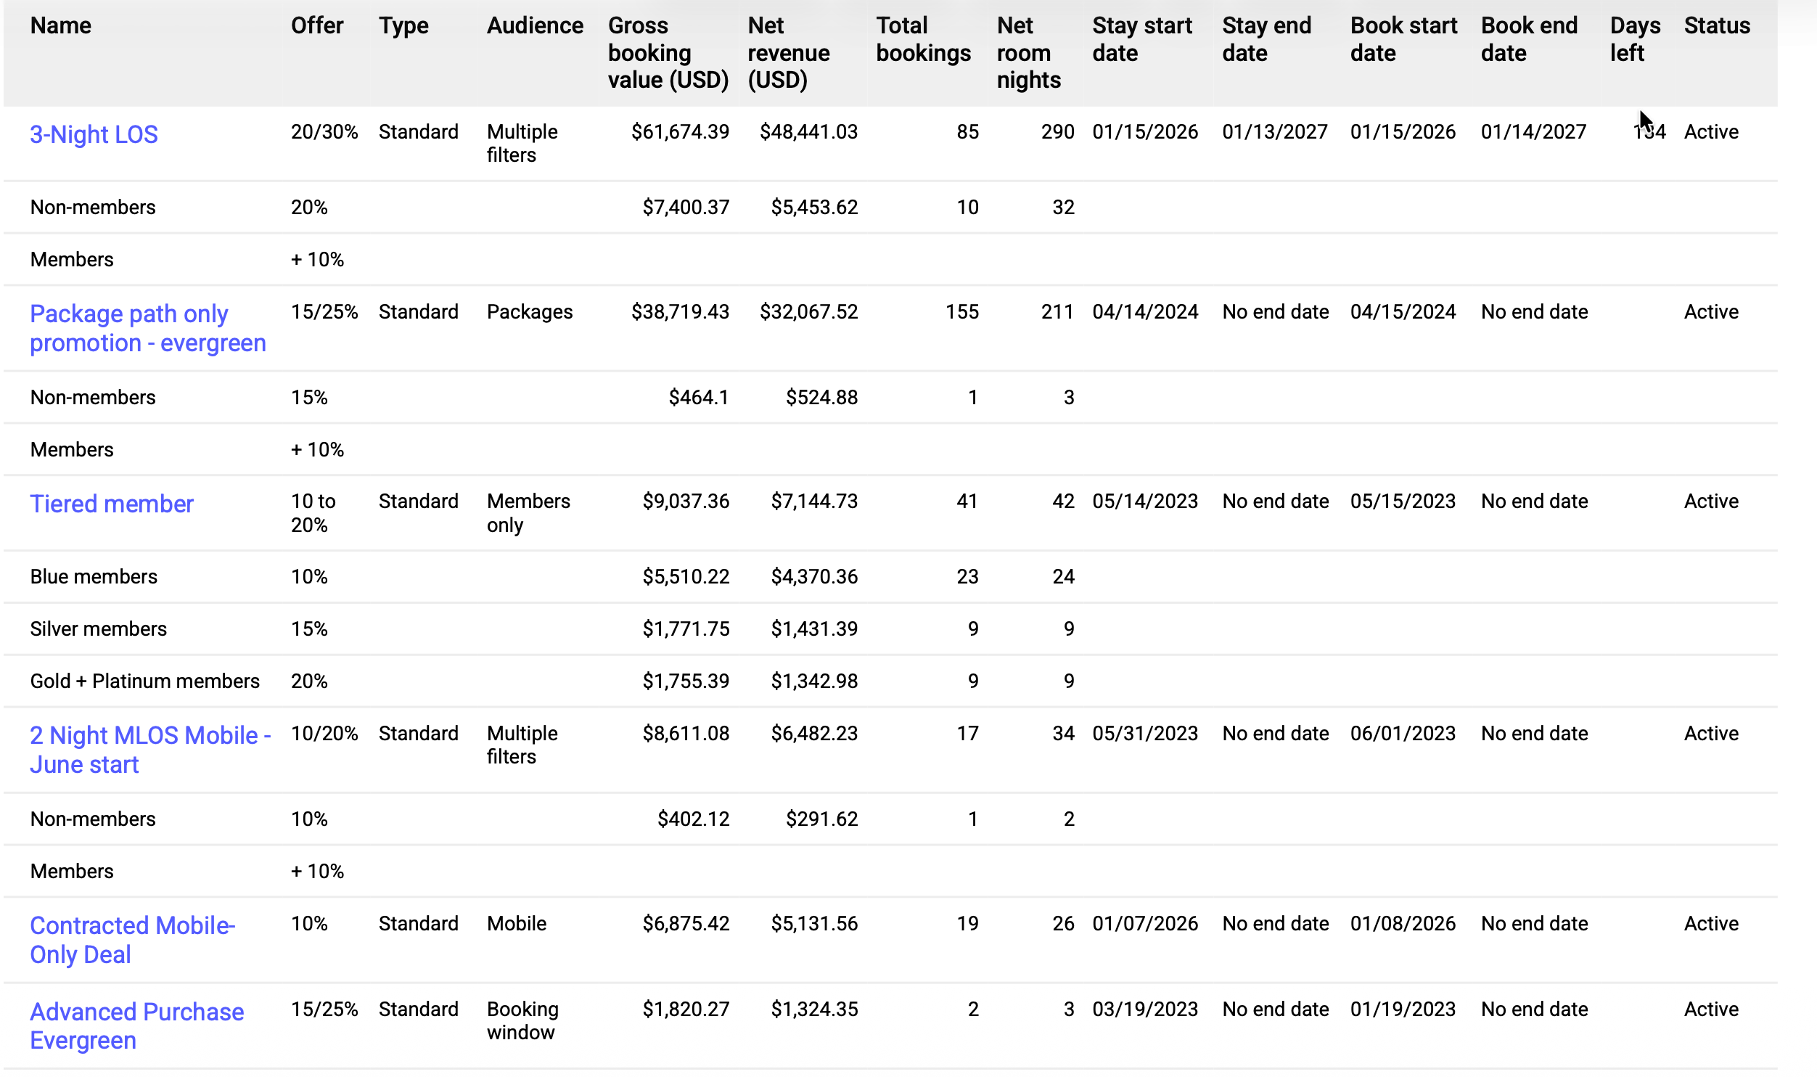

Data & Insights
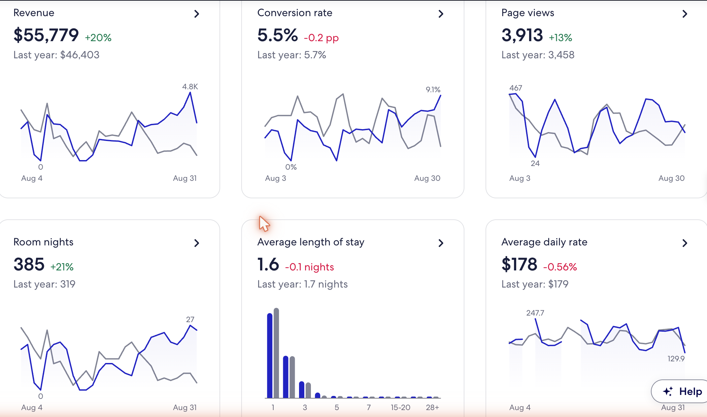

TravelAds

